Summary for C# Project: Paint

Link for Project: [https://www.youtube.com/watch?v=xyEG1e5Gnic&t=](https://www.youtube.com/watch?v=xyEG1e5Gnic&t=686s)686s

Screenshot of Code:

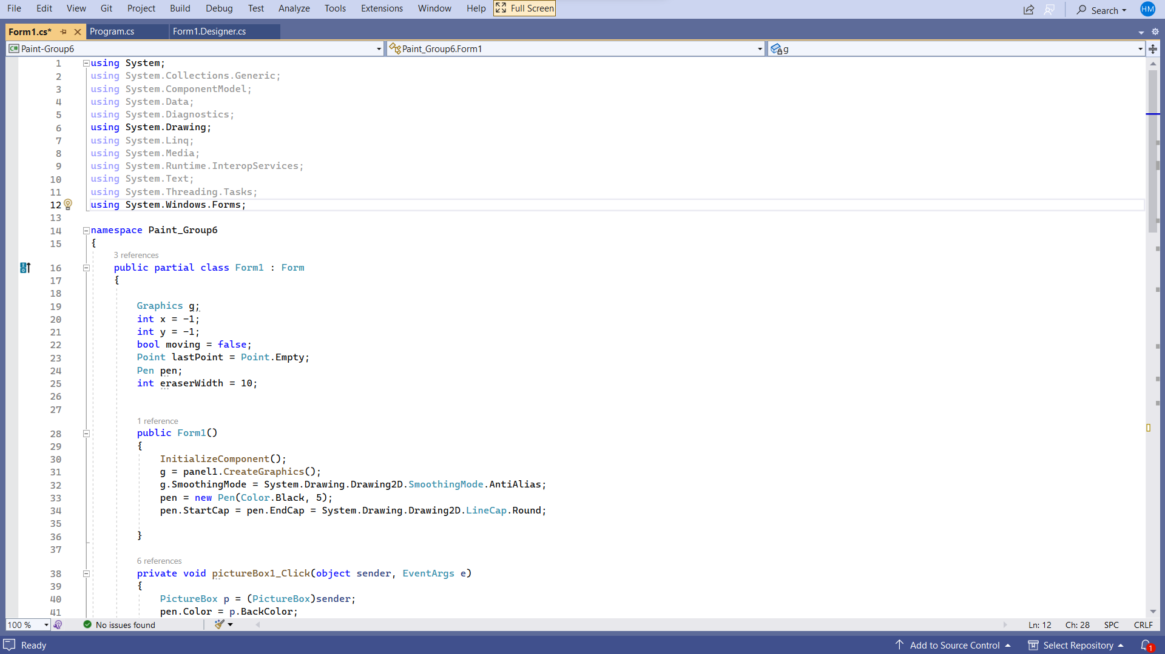

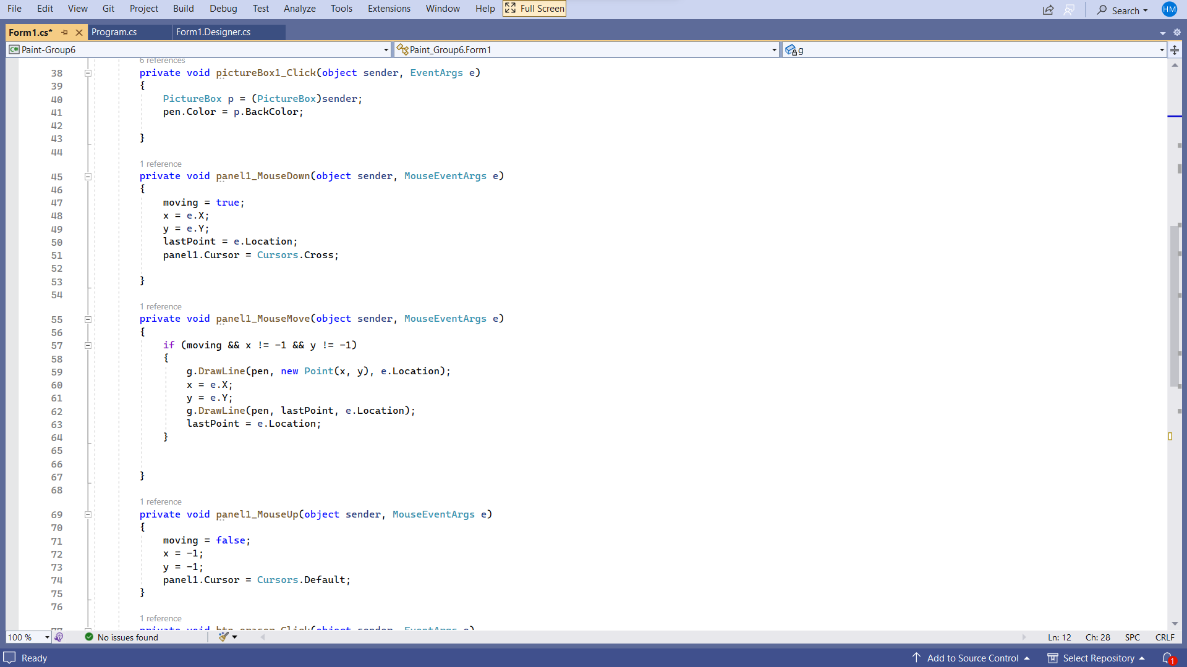

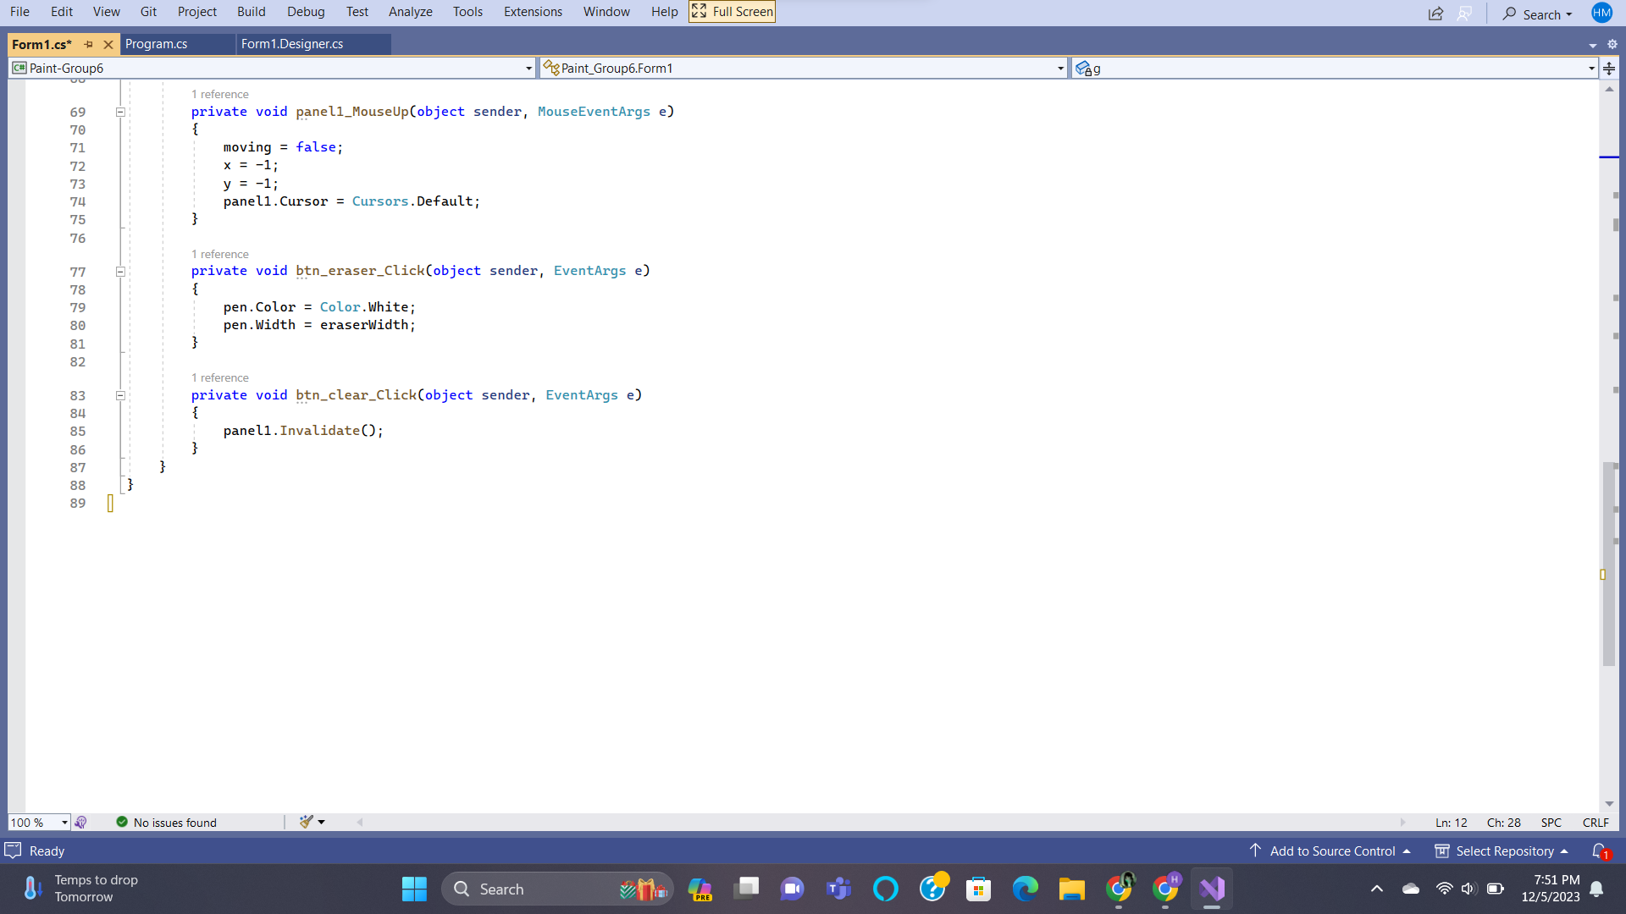

Screenshot of Output:

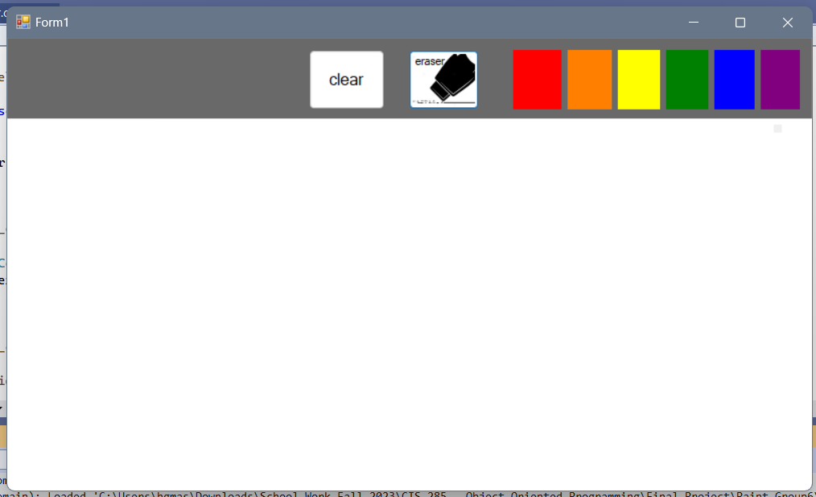

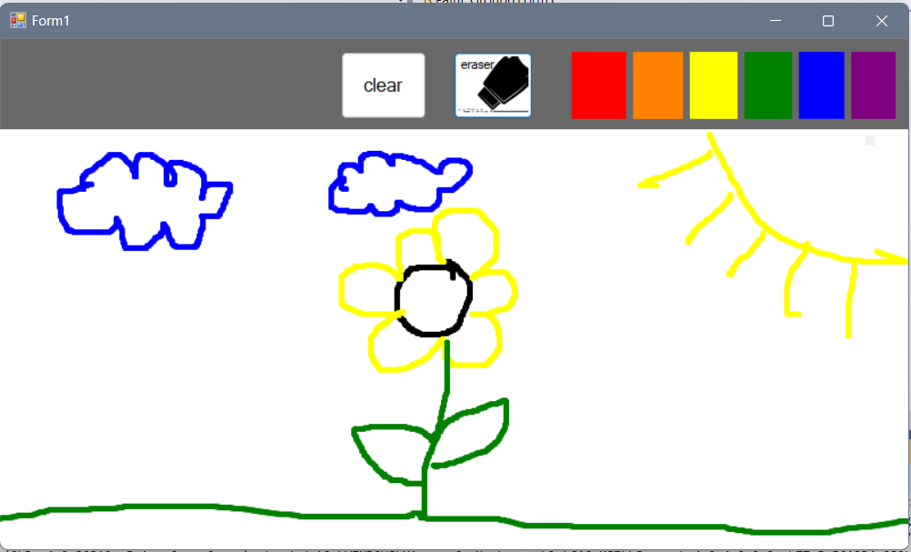

Code:

using System;

using System.Collections.Generic;

using System.ComponentModel;

using System.Data;

using System.Diagnostics;

using System.Drawing;

using System.Linq;

using System.Media;

using System.Runtime.InteropServices;

using System.Text;

using System.Threading.Tasks;

using System.Windows.Forms;

namespace Paint_Group6

{

public partial class Form1 : Form

{

Graphics g;

int x = -1;

int y = -1;

bool moving = false;

Point lastPoint = Point.Empty;

Pen pen;

int eraserWidth = 10;

public Form1()

{

InitializeComponent();

g = panel1.CreateGraphics();

g.SmoothingMode = System.Drawing.Drawing2D.SmoothingMode.AntiAlias;

pen = new Pen(Color.Black, 5);

pen.StartCap = pen.EndCap = System.Drawing.Drawing2D.LineCap.Round;

}

private void pictureBox1_Click(object sender, EventArgs e)

{

PictureBox p = (PictureBox)sender;

pen.Color = p.BackColor;

}

private void panel1_MouseDown(object sender, MouseEventArgs e)

{

moving = true;

x = e.X;

y = e.Y;

lastPoint = e.Location;

panel1.Cursor = Cursors.Cross;

}

private void panel1_MouseMove(object sender, MouseEventArgs e)

{

if (moving && x != -1 && y != -1)

{

g.DrawLine(pen, new Point(x, y), e.Location);

x = e.X;

y = e.Y;

g.DrawLine(pen, lastPoint, e.Location);

lastPoint = e.Location;

}

}

private void panel1_MouseUp(object sender, MouseEventArgs e)

{

moving = false;

x = -1;

y = -1;

panel1.Cursor = Cursors.Default;

}

private void btn_eraser_Click(object sender, EventArgs e)

{

pen.Color = Color.White;

pen.Width = eraserWidth;

}

private void btn_clear_Click(object sender, EventArgs e)

{

panel1.Invalidate();

}

}

}

Summary:

This project is a paint project. It is like Microsoft Paint but a simpler version. You can paint with assorted colors from the option selected. You can also erase any mistake you make while painting. If you need to clear the screen, there is a clear button to completely clear the screen of everything.

Line 14-25

This line of code is used for setting up for the user to paint. The items set up are the canvas, the cursor's start position on the x and y, the pen used to draw, and the width of the eraser.

Line 28-36

This line of code sets everything in place. It creates the canvas; ready the pen and it is starting color as black, and tells the computer where the pen starts and stops

Line 38-43

This line of code is used when the user draws on the canvas. It lets the canvas know it is being drawn on. It also lets the canvas know the pen should use black to paint.

Line 45-53

This line of code is used for moving the cursor down the canvas. If the mouse moves down, the code will allow it to move down using the x and y coordinates to display where it is moving down on the canvas.

Line 55-67

This line of code lets the cursor move around the canvas. It lets the canvas know where the mouse is by using the x and y coordinates to display where it is moving at. It also lets the canvas know where the pen is drawing by using the x and y coordinates and where it starts and stop drawing to display it

Line 69-75

This line of code is used for moving the cursor up the canvas. If the mouse moves up, the code will allow it to move up using the x and y coordinates to display where it is moving up the canvas.

Line 77-81

This line of code is used for erasing anything on the canvas. When you want to erase something in a canvas, it changes the color of the pen to white and changes to the width of the eraser.

Line 83-87

This line of code is used for clearing the screen. When you want to scl